Geethanjali organized its Alumni Meet on 25th December 2023. The dates of this Meet were declared in the month of October itself and the news spread far and wide. Many of the alumni played active role in contacting their batch mates and others. There was special enthusiasm in all the batches. It was a great pleasure to know about their accomplishments in professional lives. Most of them were visiting their Alma Mater for the first time since their graduation, and naturally were thrilled to meet each other. Few alumni attended the Meet with their spouses and kids.
The Principal, Dr. M Ravi Kumar, Secretary, G.R.Ravinder Reddy, welcomed the Alumni and Faculty. Principal, GCOP gave a brief on the growth of institution and welcomed alumni to visit the campus and to motivate the students of Geethanjali. Secretary Sir stressed on the importance of Alumni visiting the institute to hold students in various aspects and said alumni are the brand ambassadors of the Institution and a very vibrant relationship must be established and nurtured. Vote of thanks was given by Dr. N Anjaneyulu ,Alumni association secretary and he thanked the various organizers alumni members of the event. He also thanked the management of geethanjali college of pharmacy for the support and guidance which has made alumni meet 2022 a grand success.
Schedule for Alumni meet 2023
Sl. No | Name of the event | Time
1 | Registration and Alumni forms distribution | 6:00 PM
2 | Singing performance by students | 6:25 PM
3 | Dance performance by students | 7:00 PM
4 | Address by Dr. Ravi Kumar, Principal, GCP | 7:05 PM
5 | Address by Dr. S Udaya Kumar, Principal, GCET | 7:10 PM
6 | Address by Mr. G. R. Ravinder Reddy, Chairman, GCET | 7:15 PM
7 | Felicitation of Distinguished Alumni | 7:30 PM
7 | Experiences of Alumni | 7:45 PM
8 | Dinner | 800 PM
9 | Departure of Buses | 9:00 PM

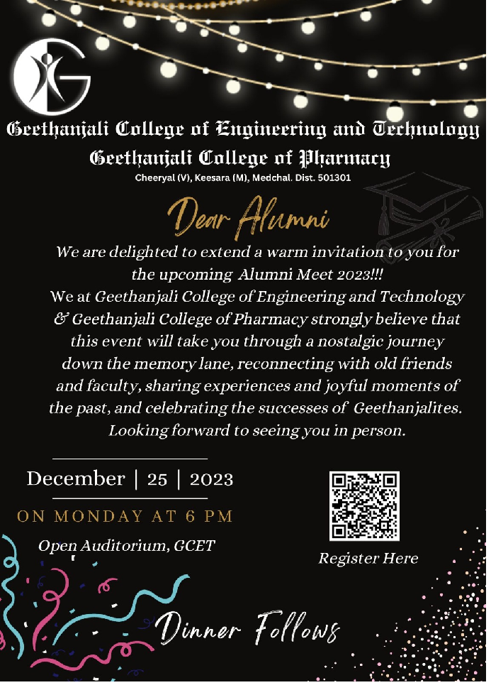
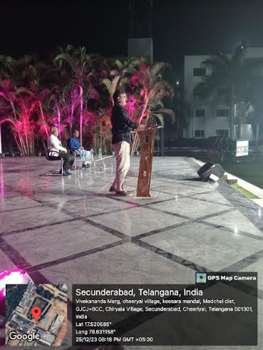
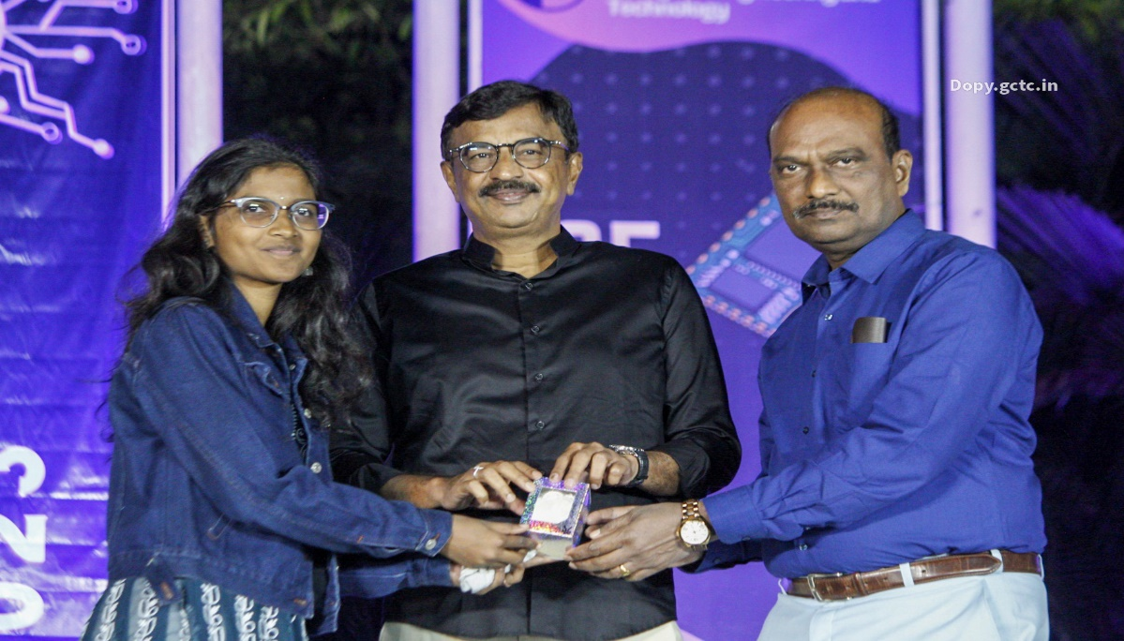

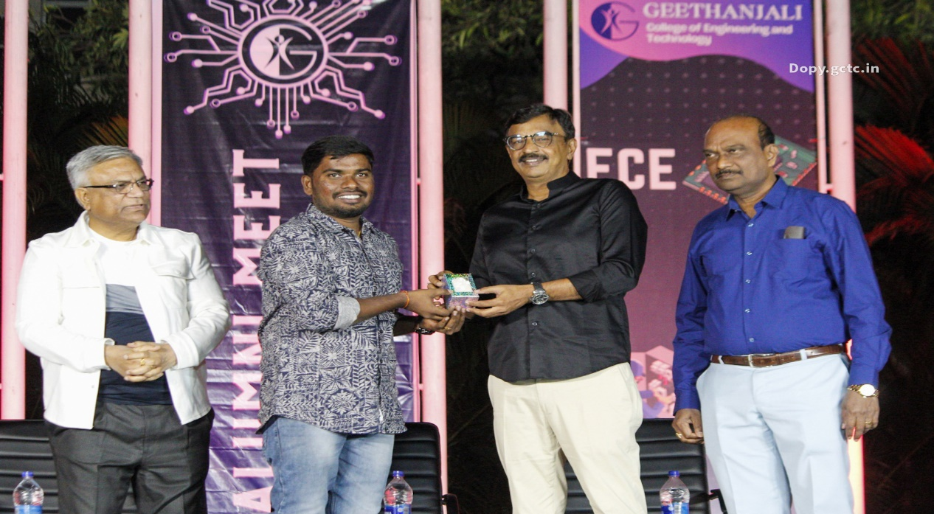

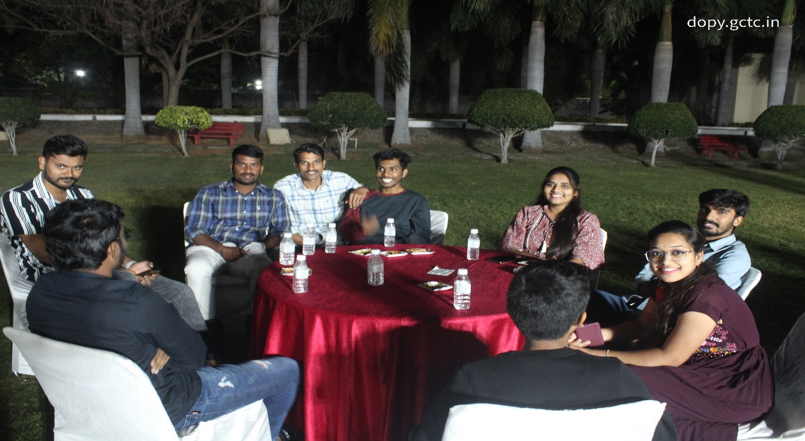
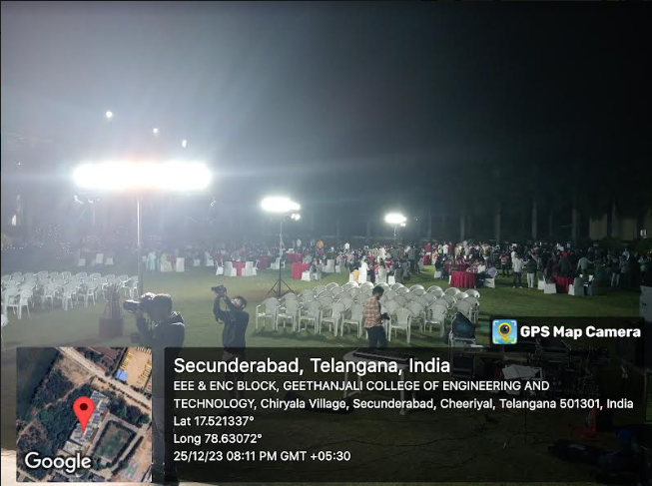

List of Alumni being Feliciatated:
SNo | Name of the Alumni | Department | Achievement
1 | G HARSHAVARDHAN | CSE | Employee at Commvault with a package of 31 lakhs
2 | Ramesh Endrala | Pharmacy | Associate manager  Global QMS, Novartis Health Care Pvt. LTD.  Hyderabad salary package - 18lacks
3 | T. Sai Kinnera | Pharmacy | Pursuing Pharma MBA, NIPER
4 | B.Karthik | CE | Pursuing Ph.D. at IISC Bangalore.
5 | Ch.Vedamithra | CE | Pursuing MBA at IIT Bombay
6 | M.KalyanaRamanuja Swamy | ECE | Developed Websites for college
7 | Ganesh | EEE | Pursuing MTech at IIT Bombay

Incharge Principal

